**WS14-EXAM INSPECTION QUESTION 33**

**CODE**

1) running program /10 pts.

2) Printing books on screen /10 pts.

3) Total amount of money for the books /10 pts.

4) Code Quality /10 pts.

5) UML Class Diagram /10 pts

**14 CORREA RUIZ KERLY YADIRA**

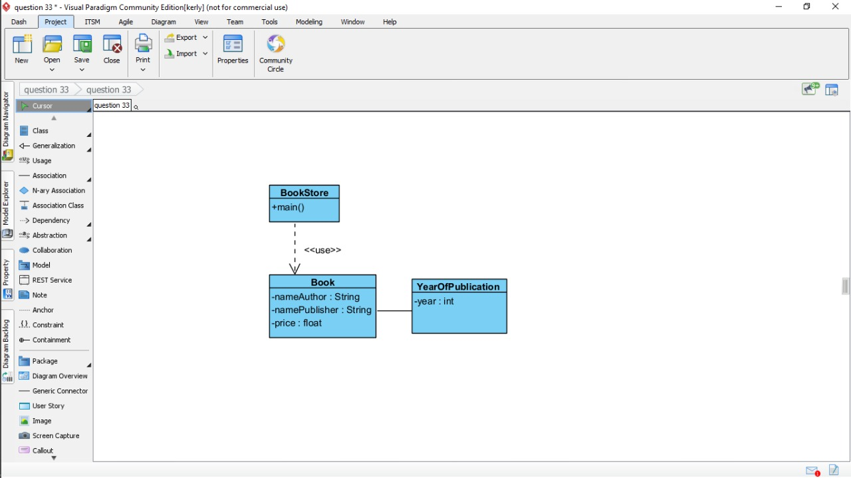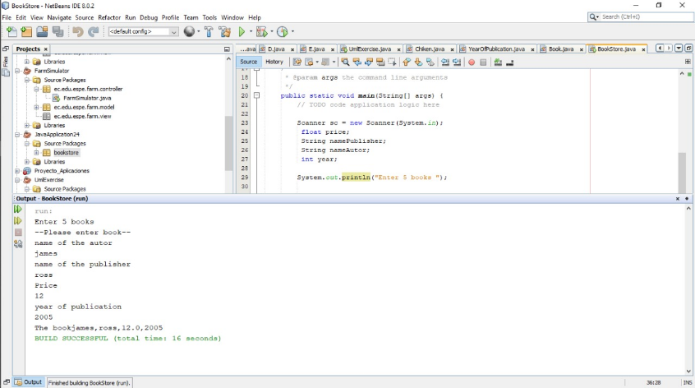

Inspector:Darling Cruz

1) running program                           5 /10 pts.

2) Printing books on screen                           7 /10 pts.

3) Total amount of money for the books         5 /10 pts.

4) Code Quality               7/10 pts.

5) UML Class Diagram                             8 /10 pts

TOTAL                                            32/50

**15 CRUZ PANTOJA DARLING MICAELA**

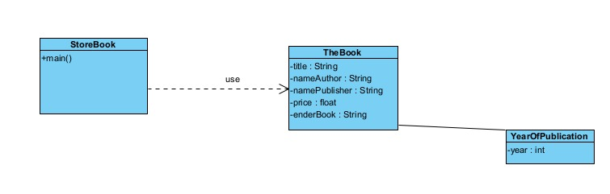

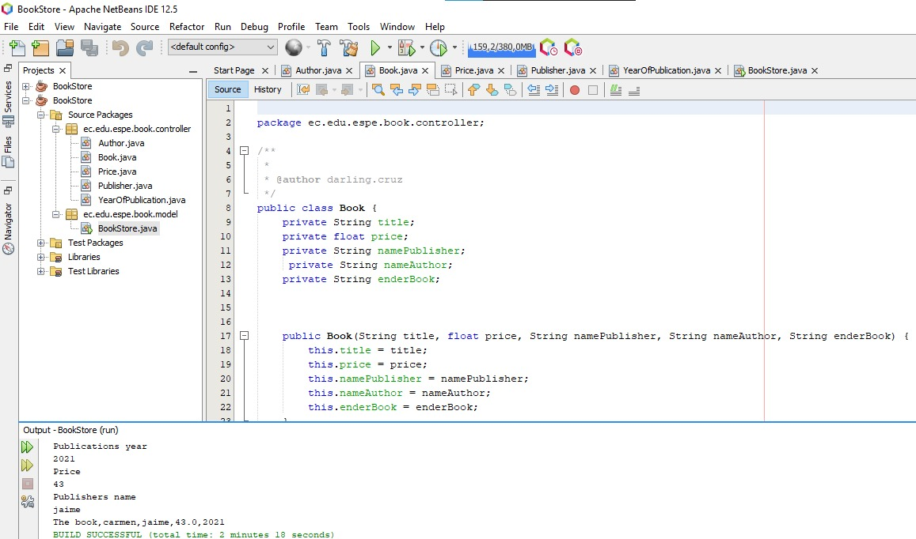

1) running program                                       5/10 pts.   
2) Printing books on screen                                       7/10 pts.   
3) Total amount of money for the books                     5/10 pts.    
4) Code Quality                     6/10 pts.   
5) UML Class Diagram                                         10/10 pts  
  
Total:                                                                                    33/50 pts